**Project Ideas**

1. Use BEM code and blade image files to derive Lift and Drags coefficients from commercial wind turbine
2. Quintessa

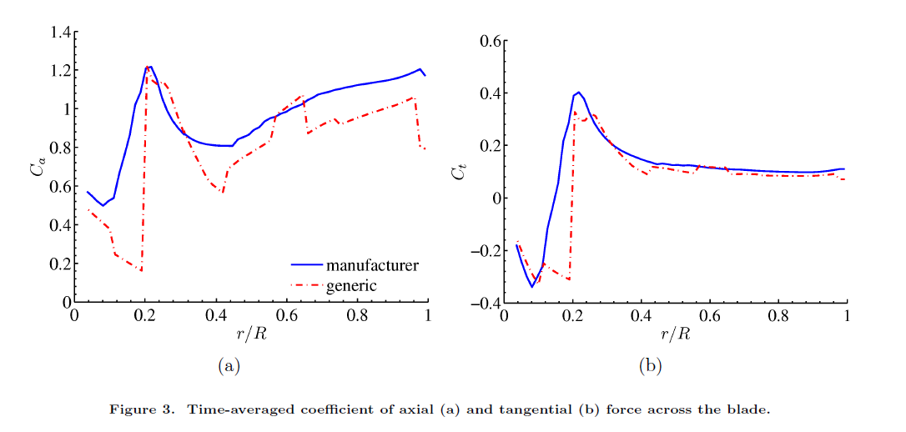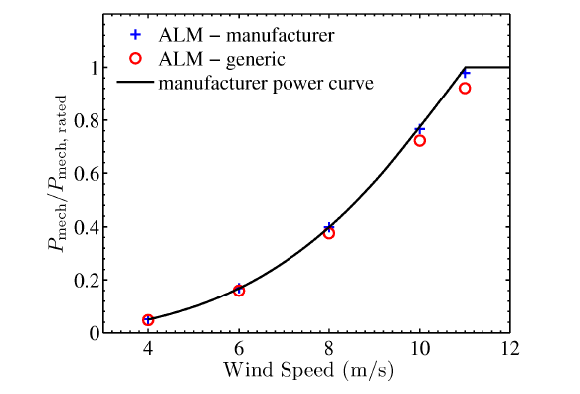

A Comparison Between Wind Turbine Aerodynamics Model Output When Using Generic Versus Actual Turbine Characterization as Input, Matthew J. Church2) Develop a coded version of a turbine simulator using MATLAB and some of its differential equation solver packages (see example)

1. QBlade Integration with MATLAB or MBDyn Model (adapting existing models of other turbines)
2. Develop Visual Interface for ACTOS